Rook endgame tips

One common way to discover a good plan endgame is to visualise what the position would look like without the pieces on the board. If the pawn ending is winning for you exchange the pieces. If it is not keep them on!
Look at this position:
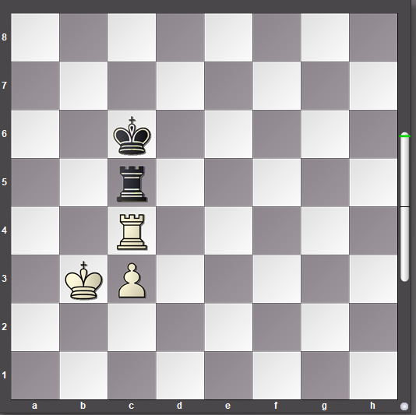
White can see that the pawn ending is winning if the white king can get in front of the passed pawn. Therefore white forces black to exchange rooks with 1.Kb3–b4 Rc5xc4+ 2.Kb4xc4 and white has achieved the desired position with the king in front of the passed pawn.

Notice it would be a mistake to exchange rooks with 1.Rc4xc5+ Kc6xc5 because in that case black would be able to prevent the white king from ever being able to get in front of the passed pawn and the position would be drawn.

It is vital to know how to stop an enemy passed pawn from achieving promotion.

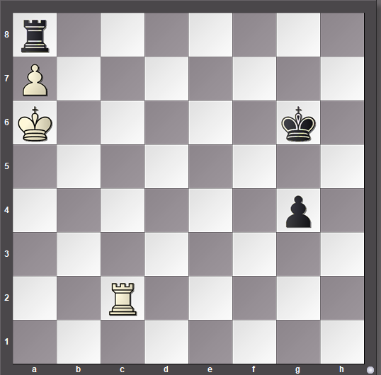

Here is a good example of the correct technique.
Obviously white can force the win of the black rook for the a pawn at any time by playing Kg7. White’s main problem is how to prevent the black king shepherding the black pawn down the board until white will have to give up the rook in return. White’s king will obviously be far too far away to help. The correct technique is to use the white rook to cut off the black king along the 5th rank. 1.Rc2–c5 Now black is helpless. If the pawn tries to rush down the board the rook can stop it easily: 1…g4–g3 When the black pawn reaches the 3rd rank the rook can win it with 2.Rc5–c3 g3–g2 3.Rc3–g3+ and, after capturing the pawn, white will play Kg7, win black’s rook and then proceed to give mate with the king and rook.

If black tries to mark time with the king without advancing the pawn white will force the win of the rook and then bring the king over to help capture the black pawn: 1...Kg6–f6 2.Ka6–b7 Ra8xa7+ 3.Kb7xa7 Kf6–g6 4.Ka7–b6 etc..

Endings in general and rook endgames in particular can be extremely tactical. Tricks and traps abound. Look at this position:

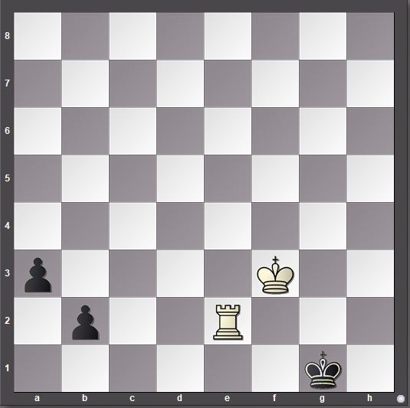

Black’ pawns seem to be very threatening. However, white has a clever tactic which forces a totally winning position in just a couple of moves: 1.Re2–e1+ and black has only one move 1…Kg1–h2 and now 2.Re1–b1 leaves black with only two options 2…a3–a2 loses both pawns after 3.Rb1xb2 check!
Black’ other option at move two is even worse: 2...Kh2–h3 3.Rb1–h1 checkmate

You should always be alert to tactical possibilities. Of course, having good calculation skills is vital.

Here is another typical tactic:
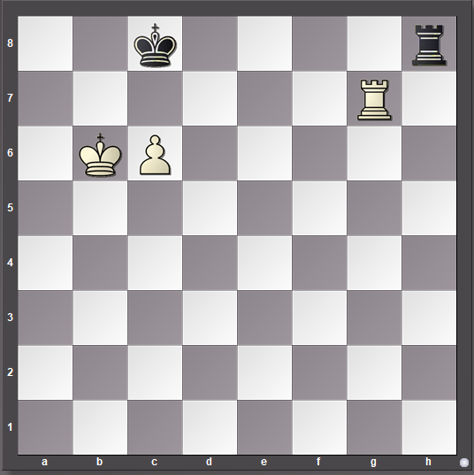
The presence of the white king and pawn on the 6th rank carries the massive threat of mate. In this case the squares a7, b7, c7 and d7 are all covered.
White wins by positioning the rook on the side of the board where the white king is.

1.Rg7–a7 Kc8–b8 [1...Kc8–d8 2.Ra7–a8+ Kd8–e7 3.Ra8xh8+–; 1...Rh8–h6
2.Ra7–a8#]

2.c6–c7+ Kb8–c8 3.Ra7–a8+forcing the winning capture of the black rook

Consider this position:

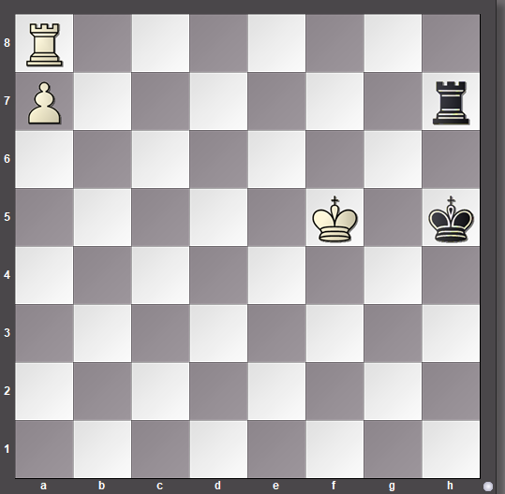

Under normal circumstances having the rook in front of the passed pawn is a serious disadvantage. Here, however, there is a feature of the position that enables white to win anyway. That feature is the fact that the black king is being hemmed in on the edge of the board by the white king.

1.Ra8–f8 wins by preventing a saving black check on f7 1...Kh5–h4 [1...Rh7xa7 2.Rf8–h8+ Ra7–h7 3.Rh8xh7#] 2.a7–a8Q winning easily.

Notice no other rook move will do – for example 1.Ra8–e8 Rh7–f7+ 2.Kf5–e4 Rf7xa7

By being alert to the tactics and calculating carefully white was able to exploit a rare feature of the position.

You should focus on the need to exploit your advantages and not allow yourself to be distracted by random captures.

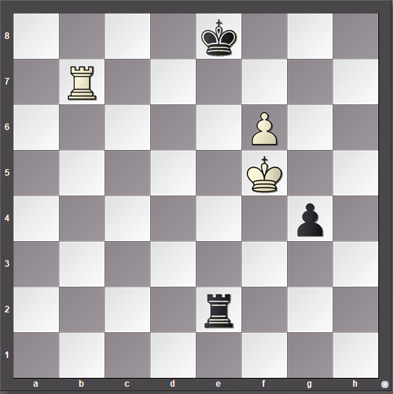

Here white can capture black’s last pawn, but if the pawn is taken black will be able to draw the game by checking the white king whenever it tries to help the white passed pawn to advance. Instead the winning method is to use the black pawn as a shield protecting the white king from checks:

1.Kf5–g6 Re2–f2 2.f6–f7+ Ke8–f8 3.Rb7–b8+ Kf8–e7 4.Rb8–e8+ and white will promote the pawn with an easy win in prospect.

Do not be distracted by greed!

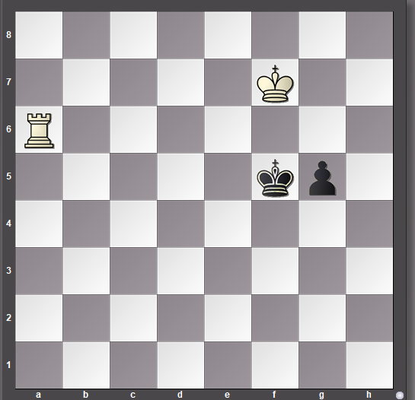

In this case white cannot cut the black king off along the 5th rank, but by combining the white king and rook accurately the black pawn can be captured:

1.Ra6–f6+ Kf5–e4 [1...Kf5–g4 2.Kf7–g6 Kg4–h4 3.Kg6–f5 g5–g4 4.Rf6–g6+–]

2.Kf7–g6 g5–g4 3.Kg6–h5 g4–g3 4.Kh5–h4 g3–g2 5.Rf6–g6 Ke4–f3 6.Kh4–h3 and the black pawn will drop off.

Careful, accurate calculation allowed white to achieve the victory.

Now for another example of a typical tactic:

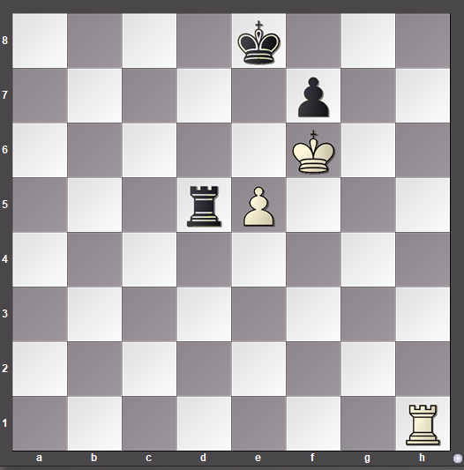

At first glance this position looks drawish, buy whit can exploit the fact that black’s rook is close to the white king to execute a clever trick: 1.e5–e6 f7xe6 [1...Rd5–d6 2.Rh1–h8#; 1...Ke8–d8 2.e6xf7 Rd5–d6+ 3.Kf6–e5+–]

2.Kf6xe6 Ke8–f8 [2...Rd5–d3 3.Rh1–h8#] 3.Ke6xd5 It turned out that white’s alertness meant that black only had a choice between losing the rook or getting mated.

Such tactics can be easy to miss – eternal vigilance is required so that you do not let a momentary opportunity slip by.

